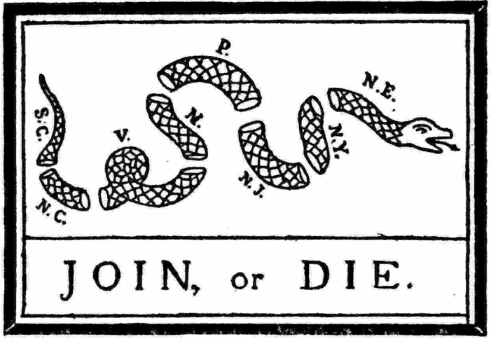
Unit 3 Day 1
- In what ways was the French and Indian War a turning point in the relationship between England and its American colonies?
- Read through the “Albany Plan of Union” with a partner. Once you have finished reading through the plan, summarize the plan in your own words on a clean sheet of paper in your history notebooks. Share your summary with your partner and then discuss how the political cartoon at the top of this page relates to the Albany Plan.

- Gather into large group and discuss your written summaries, the relationship between the Albany Plan and the “Join or Die” cartoon, and Q/A over the causes and effects of the French and Indian War.

- Select two other people that you could work efficiently with and begin analyzing the six documents using the HIPPY method. Once all six documents have been analyzed, categorize the documents as being: political, economic, or ideological. (Some may be in more than one category)

- As a group, craft an introductory paragraph to the following question:
In what ways did the French and Indian War (1754-1763), alter the political, economic, and ideological relations between Britain and its American colonies?
- Gather into large group to discuss your paragraphs and the effects of the French and Indian War.

