Questions 1-5 refer to the photograph below.
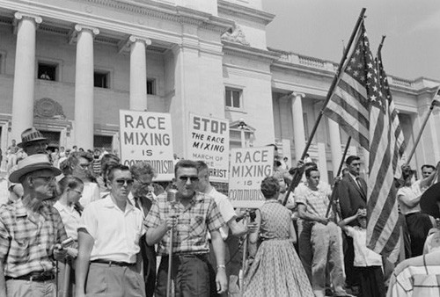

- Which recurring constitutional debate since the founding of the nation most underlies the controversy being depicted in the above photo?
(A) Proper limitations on the practice of free speech under the Constitution
(B) Need for government officials to heed popular grassroots efforts
(C) Power of the federal government over that of states
(D) Legal qualifications for voting rights

- Which federal measure most directly led to the protest depicted in the above photo?
(A) Congressional passage of the Civil Rights Act
(B) Executive branch desegregation of the armed services
(C) Judicial decision overturning the precedent set by Plessy v. Ferguson
(D) Judicial decision upholding the idea of “separate, but equal”

- Which of the following best explains the central goal of the African American civil rights movement at the first half of the 20th century and how it had evolved by the latter half?
(A) Ending legal segregation to ending socialized discriminatory practices
(B) Ending the system of sharecropping and tenant farming to overturning segregation laws
(C) Obtaining citizenship under the Constitution to working for passage of a voting rights act
(D) Stopping white supremacy actions, like lynchings, to securing laws of equal opportunity

- Which of the following best describes why the event that led to the protest in the above photo might be considered a turning point in U.S. civil rights history?
(A) It was a watershed moment by raising public outrage in the North regarding segregation laws the South had implemented since the end of Reconstruction.
(B) It jump-started the movement for improved education for African Americans in the South.
(C) By breaking the “separate, but equal” doctrine, it began the eventual dismantling of segregation laws.
(D) It brought into prominence the political debate over federal power vs. states’ power.
- Which of the following anti-desegregation actions most forced federal executive interference in the South?
(A) A continuing series of large rallies by white southerners, like that in the photo, which sometimes ended in violence.
(B) State and municipal defiance of federal court orders and accompanying violence
(C) The urging by southern members of Congress to defy the U.S. Supreme Court rulings regarding segregation
(D) Local police barricading of entrances to “whites only” public establishments against entry by African Americans

Questions 6-10 refer to the excerpt below.
“By the end of 1949, only one out of three heroines in the women’s magazines was a career woman—and she was shown in the act of renouncing her career and discovering that what she really wanted to be was a housewife. In 1958, and again in 1959, I went through issue after issue of the three major women’s magazines (the fourth, Woman’s Home Companion, had died) without finding a single heroine who had a career, a commitment to any work, art, profession, or mission in the world, other than “Occupation: housewife.” Only one in a hundred heroines had a job; even the young unmarried heroines no longer worked except at snaring a husband.”
--Betty Friedan, journalist, The Feminine Mystique, published in 1963
- The mid-20th century idealization of womanhood as described by Friedan is most like which conception of womanhood from the 19th century?
(A) Limiting of “women’s” work to social reform efforts
(B) Women’s role earning income outside the home, such as in the factories
(C) Women’s separate sphere of domesticity
(D) Moral superiority of women
- Critiques like Friedan’s above helped illuminate the contradiction in the idealized role for women versus which economic reality concerning women’s roles by the latter half of the 20th century?
- Women were the dominant consumer decision-makers.
- Increasing numbers of women were impoverished.
- Increasing numbers of married women were in the workforce.
- More jobs were available for women.

- For which labor issue, challenged by women since the early 19th century, did the women’s movement make some legal progress by the mid- to late 20th century?
- Unequal pay
- Unsafe physical working conditions
- Society’s view of women’s employment outside of the home as immoral
- Long working hours

- Which of the following best describes a key motivator for the feminist movement of Friedan’s era, which also played a key role in instigating the women’s movement during the antebellum period?
- Women’s desire to refine the domestic role of women rather than redefine it
- Frustration at restrictions posed by societal ideas of proper roles for women vs. that of men
- Desire for equality in voting rights and laws of property ownership
- Women’s struggle to alleviate poverty within their communities

- Which provides the best argument for why the feminist movement of the latter 20th century was quicker to achieve gains and to garner public support than the feminist movements of earlier eras?
- Women of the mid-20th century were more likely to experience poverty or economic struggle than in the past.
- Women of the mid-19th century generally believed that they lacked the possibility of making social or economic progress.
- Making amendments to the U.S. Constitution became an easier process by the 20th century.
- Women had experienced greater economic and social opportunities during the 20th century than in the past.

- The purpose of the 1964 Freedom Summer in Mississippi was to
- protest the escalation of the Vietnam War
- help and encourage blacks to become registered voters
- force the Interstate Commerce Commission to declare segregated transportation facilities unconstitutional
- persuade the state legislature to ratify the Equal Rights Amendment
- desegregate schools

- Martin Luther King's philosophy of civil disobedience incorporated
- the spirit of evangelical Christianity's sacrifice and redemption
- nonviolent resistance
- direct action
- ideas of Thoreau and Gandhi
- all of the above

