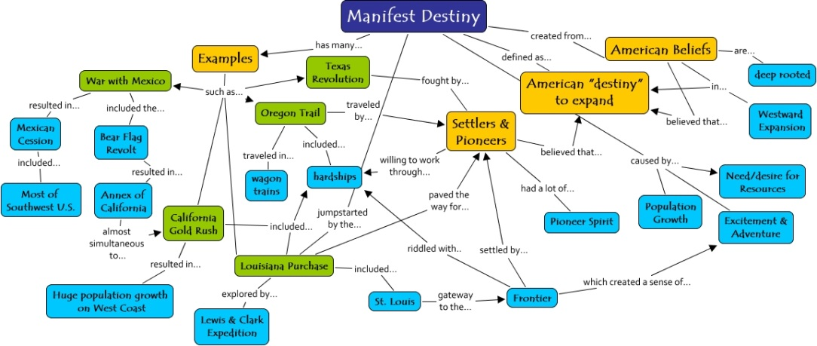
Unit 5 Day 2
- Look at the painting on the whiteboard and list everything you see in the next 180 seconds.
- The floating white woman in this painting is heading west. What do you think she represents? How is this symbolized in the painting? What else is symbolized in the painting?
- Read through the excerpts from O’Sullivan on the back of the agenda and answer the questions. When you are done, quietly proceed to large group and be prepared to discuss the following.
- Why did Americans think they were so special?
- Are you surprised by the reasons that O’Sullivan gives for expansion?
- This theory that Americans are special is called “American Exceptionalism”. It’s this idea that America has had such a unique history and has become so powerful that there’s something really special about it. What do you think about this theory?
- Use any resources at your disposal, including the three PowerPoints that Mr. Martin posted in the “Assignments/Resources” section of the class website to gather evidence to support your group’s position on the following question:
Analyze how western expansion contributed to growing sectional tensions between the North and South. Confine your answer to the period from 1821 to 1848.
- Gather into large group to:
- Clarify any content questions over the Texas Revolution, Oregon Boundary dispute, and/or Mexican-American War.
- Discuss your group’s answer to the essential question in agenda item 3.

“Manifest Destiny” and the Writings of John O’Sullivan
John O’Sullivan, "The Great Nation of Futurity" 1839.
Our national birth (and the Declaration of Independence) was the beginning of a new history, which separates us from the past and connects us only with the future. We are the nation of progress, of individual freedom, of universal enfranchisement. Our future history will be to establish on earth the moral dignity and salvation of man -- the undeniable truth and goodness of God. America has been chosen for this mission among all the nations of the world, which are shut out from the life-giving light of truth. Her high example shall put an end to the tyranny of kings, and carry the happy news of peace and good will to millions who now endure an existence hardly better than that of beasts of the field. Who, then, can doubt that our country is destined to be the great nation of the future?
- What does John O’Sullivan think America stands for?
- What, according to John O’Sullivan, is America’s mission?
John O’Sullivan, “Annexation” 1845.
It is time now for all opposition to annexation of Texas to stop. . . Texas is now ours. She is no longer to us a mere geographical space. She is no longer to us a mere country on the map....The time has come for everyone to stop treating Texas as an alien, and to stop thwarting our policy and hampering our power, limiting our greatness and checking the fulfillment of our manifest destiny to overspread the continent allotted by Providence for the free development of our yearly multiplying millions.
- What do you think John O’Sullivan means by “our manifest destiny to overspread the continent allotted by Providence for the free development of our yearly multiplying millions”?
- Based on these two documents, how did Americans feel about expanding westward?

