American History
Sources: Kenneth C. Davis, Don’t Know Much About History (2003); Howard Zinn, A People’s History of the United States, 1492-Present (2003); America (2002)

The Rise of Big Business
The term “big business” refers to large-scale financial or business activities. It does not simply mean a company with a lot of capital (money), but it also includes new technology, and smart, ambitious leaders who control the company. The time period after the Civil War saw many great inventions: the typewriter, phonograph, sewing machine, the telegraph (Samuel F.B. Morse), the telephone (Alexander Graham Bell), electric power including the light bulb and electric grids controlled by central power stations (Thomas Edison, the “Wizard of Menlo Park”), and the Bessemer process, which made it easier and more efficient to use steel for building purposes. But overshadowing all of these things are the men behind the industries that grew great and powerful during the business age. Sometimes called “Captains of Industry,” these men are considered to be powerful industrialists who helped establish and expand the wealth of America. Others refer to them as “robber barons,” meaning that they were able to get rich and make fortunes by stealing from the laboring work force who helped create them. So which term is more accurate?
The four basic economic components, or resources, are land, labor, capital, and entrepreneurship. Land, referring to natural resources, labor, referring to a work force, capital, referring to man-made resources like machinery, and entrepreneurship, referring to people willing to take on new endeavors or try new things, are essential to making our economy function. When discussing “captains of industry” or “robber barons,” we are mostly talking about the entrepreneurship component. The three most significant “captains of industry” or “robber barons” are Andrew Carnegie, John D. Rockefeller, and J.P. Morgan.
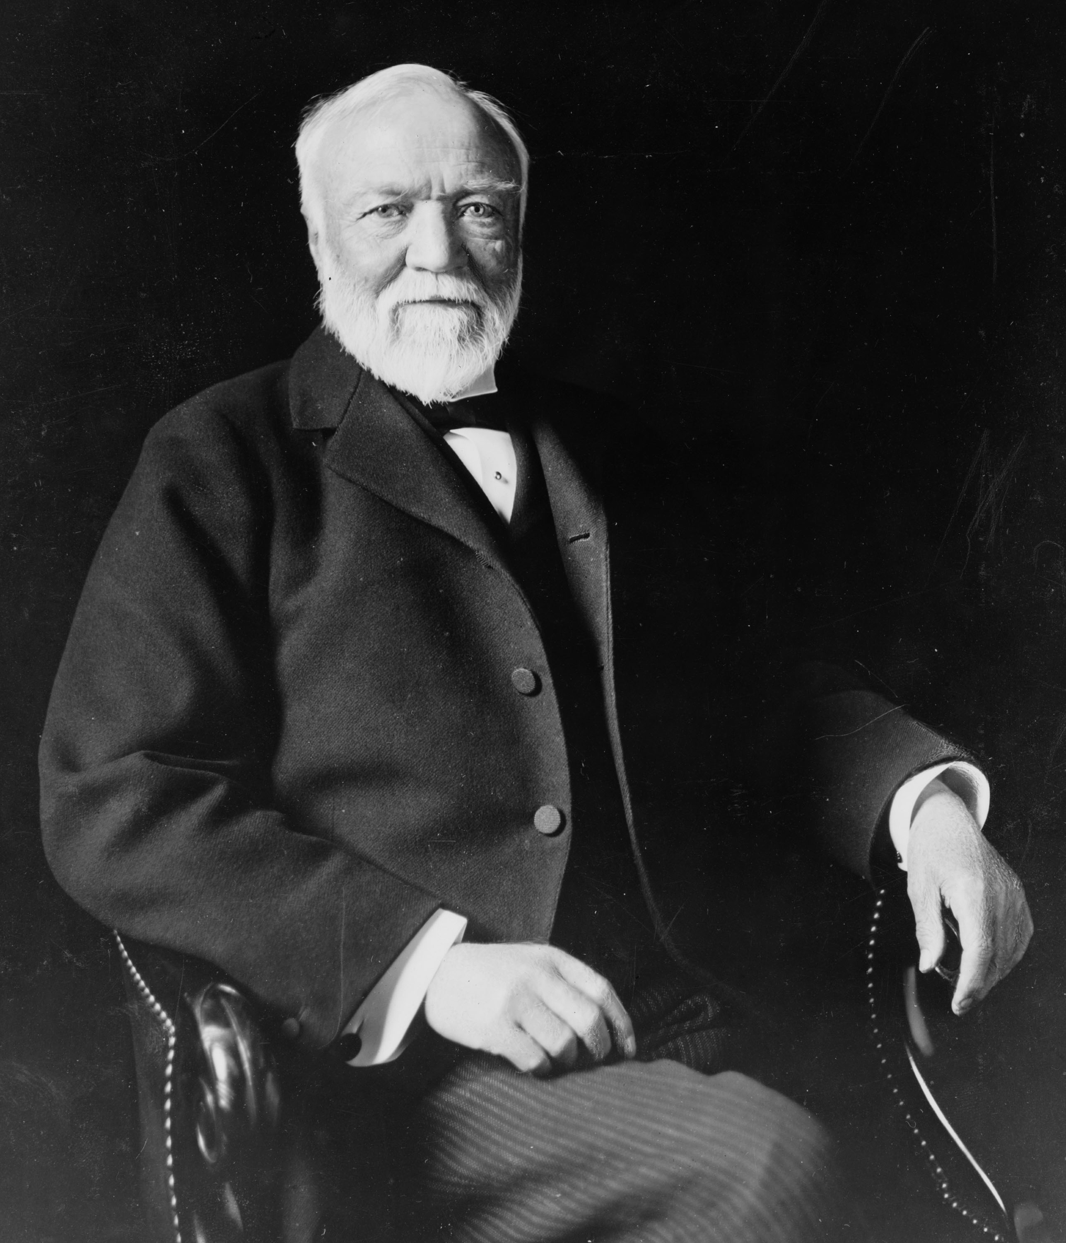
Andrew Carnegie truly is a rags-to-riches story. A Scottish immigrant, Carnegie eventually worked his way through the railroad industry to gain power of the steel industry. He had all of the qualities we see in successful businessmen: ambitious, hard-working, and able to capitalize every opportunity. After immigrating to the United States in 1848 at the age of 13, Carnegie first took a job at cotton mill. Later, he was given the job of secretary to the superintendent of the Pennsylvania Railroad Company, and when his boss took a job with the U.S. War Department, Carnegie was promoted. By 1865, Carnegie was making $50,000 a year and wanted to invest some of his money. Carnegie believed that with the development of the Bessemer process, steel would eventually become more popular than iron. In the 1870s, Carnegie created the first steel plants in Pittsburgh, Pennsylvania to use the Bessemer process. The industry exploded, Carnegie made a fortune, and in 1889 he established the Carnegie Steel Company.
Andrew Carnegie (1835-1919)
These “captains of industry” or “robber barons” used any means necessary to get ahead. They often paid very low wages for labor, and worked to pay as little as possible for resources which would maximize their profit. Often times, monopolies would develop. A monopoly is when one person or organization has complete control of a good or a service (think about playing Monopoly; the goal is to own as much of the game board as possible and to have more money than anyone else). During this time in history, most Americans believed the government should not be involved in business activity. Therefore, the government could neither tax big business, nor regulate the relationship between a business and its workers. Because of this combination, monopolies were able to flourish. One such company to benefit from this type of organization was John D. Rockefeller’s Standard Oil Company of Ohio.
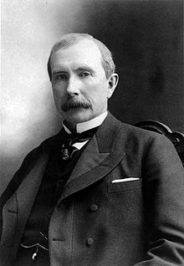
Rockefeller made his early wealth by dealing in the grain and meat industries during the Civil War. Once it was discovered that oil could be unearthed through a well, Rockefeller decided to join the oil industry in hopes of making even more money. In 1870, he established the Standard Oil Company of Ohio. Rockefeller’s true success was in how he ran his company. He had friends in the railroad industry and he was able to persuade them to give him discounts on transporting his oil. This allowed him to set Standard Oil’s prices so low that his competitors would soon be out of business. Eventually Rockefeller would be able to “buy out” his competitors. However, state laws at the time prohibited any company from owning stock in another company. So, in 1882, the owners of Standard Oil, including Rockefeller, established a “trust.” This trust would be operated by a board of trustees. The companies would give their assets to the board, and in return the board would share the profits. No laws were violated because the companies technically did not merge. Americans urged the U.S. government to take action and as a result the Sherman Anti-Trust Act was passed. This act outlawed any group of companies that acted to restrain interstate trade or commerce.
John D. Rockefeller (1839-1937)
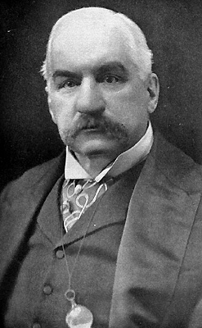
John Pierpont Morgan (J.P. for short) is another significant figure in the rise of big business. The son of a banker, J.P Morgan was able to begin making his fortune during the Civil War. Morgan managed to escape fighting in the Civil War by paying $300 to a substitute. Once the war began, Morgan purchased old, unusable rifles for $3.50 each. The rifles were then repaired and resold for $22. J.P. Morgan then began to invest in a variety of industries and eventually purchased Carnegie’s steel company for $492,000,000. Through various business deals, Morgan was able to become the financier of the times. He successfully connected the railroad industry to banks, and banks to insurance companies. By spinning a web of finance, Morgan was able to net a personal fortune of over two billion dollars.
J.P. Morgan (1837-1913)
Andrew Carnegie, John D. Rockefeller, and J.P. Morgan played a pivotal role in the growth of business and wealth in America. These men, and others, helped transform an industrial America into a developed America. Unfortunately, the personal wealth they amassed was built on the backs of the poor, ill-treated, laboring class of America.

