American History
Sources: Kevin Baker, “Lincoln Steffens: Muckraker’s Progress,” New York Times (2011); Kenneth C. Davis Don’t Know Much About History (2003); Howard Zinn, A People’s History of the United States (2003); PBS American Experience
Progressive Reform: The Failures of Progress
The industrialization that took place in the United States in the late 1800s resulted in rapid expansion; cities grew at an amazing pace, individual wealth skyrocketed for a small percentage of Americans, while poverty expanded for the others, and urban populations grew as people moved to the cities in search of jobs and with the influx of immigration. The effects of such expansion were not always positive. Unemployment, dangerous working conditions, and political and industrial corruption plagued the ever-expanding United States. Many individuals felt the need to address these issues and others in hopes of changing American society for the better. These people were called Progressives.
There is no one type of progressive. “Progressive” simply refers to political and social reformers who sought liberal change. Many progressives on the late 1800s and early 1900s were socialists. Socialism is an economic and political philosophy favoring public or government control of property and income. On the political spectrum, socialism is far left. Many socialists feel that capitalist systems (economic systems based on private property, competition, and free markets) are unfair and so socialists work to distribute wealth more equally. Even though socialism is an economic system, it often times becomes intertwined with the government, and therefore can be considered a political system as well. A much more radical belief during this time was anarchy. Anarchy is the absence of government or a state of lawlessness. While separate from socialists, anarchists played a vital role in the progressive movement.
While workers often went on strike or joined labor unions to combat immediate issues like long hours and low pay, progressive reformers sought systematic change on the national level. Progressives used scientific research to support their claims of inequality and then worked hard to publicize specific issues. Progressive reformers who worked as investigative journalists and published their findings were often called “muckrakers.” American journalists whole-heartedly embraced this term as they worked toward an overhaul of the systems they believed to be so unfair.
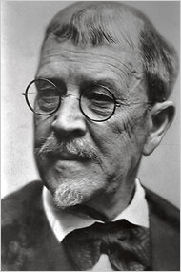
Ida M. Tarbell is most well-known for her scathing investigation of Standard Oil. McClure’s magazine ran her investigations as a series titled History of Standard Oil Company. Tarbell grew up in Pennsylvania, the daughter of an oil producer. Ida remembered her childhood fondly, commenting on the luxury in which they lived due to her father’s booming oil business. But in 1872, things changed for Ida’s family. Through means of horizontal integration, John D. Rockefeller and his Standard Oil Company were able to eliminate their competition, which included many small business owners like Tarbell’s father. Ida’s report on Standard Oil was a scathing 19-volume exposé of the unethical business practices of Rockefeller and his monopolizing effects on the industry. She used newspaper articles, court documents and testimonies, and other public records as she researched the industrial giant. While she gave him credit where credit was due (she mostly applauded his patience), she did not hesitate to depict him in a negative light, truly fitting the “robber baron” persona. She wrote, “[Standard Oil] had never played fair, and that ruined their greatness for me.” Tarbell’s work was never publicly commented on by Rockefeller himself, but sources note how truly hurt he was by her. She did not need his approval though; her work centrally places her as one of the most influential women in American history.
Lincoln Steffens was also published in McClure’s. His most famous work, The Shame of Cities, exposed political corruption in cities like Minneapolis, Chicago, and New York. But Steffens investigated much more. His investigation into the corruption on Wall Street eventually led to the creation of the Federal Reserve System. He noted that the average American detested the government and politics while praising big business, never connecting the two. And, despite having big friends in politics, like Theodore Roosevelt and Woodrow Wilson, he never shied away from telling the truth as he saw it.
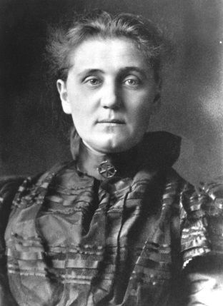
Jane Addams co-founded Hull House, a settlement house in Chicago that would eventually provide basic education and health care to hundreds of thousands of immigrants. Addams and her colleagues bought a run-down mansion in a poor neighborhood of Chicago. They first decided to open a day care center for immigrant families who lived in the tenement-filled neighborhood. The day care center not only provided working mothers with a safe environment in which to leave their children but it also gave the children one meal a day. The Hull House later expanded to offering kindergarten classes for small children, English classes for newly-arrived immigrants, and trade classes to teach adults skills they could transfer to the workplace. In addition, Jane Addams also fought for better working conditions for minors which eventually led to a change in Illinois legislation and she fought to protect juvenile offenders. Hungry and cold youths would steal to heat their homes or feed their families. Once convicted, they were often sent to prisons with hardened criminals. Jane Addams’ work led to the creation of a juvenile court system which handled cases of juvenile offenders separately from that of adults.
Other progressive reformers worked hard throughout the late 1800s and early 1900s to improve the horrible conditions they saw. They fought crime and poverty, worked for equality and justice, and most importantly, advocated for change that would better society. They slayed giants and fought for the underdog. And even though most of their work was done at a local level, they would set the stage for later activists to fight for complete overhauls of the American system. Unfortunately, for most of these progressive reformers, the American ideology was firmly against government assistance of the less fortunate. It would take a war coupled with an economic boom and bust to change that opinion.

